**Battleship in Java**, by Manos Kontakis

**The Making**

**For the development of the Battleship needed:**(From first to last)

1. Many hours per day studying:

*“Java 6”.*

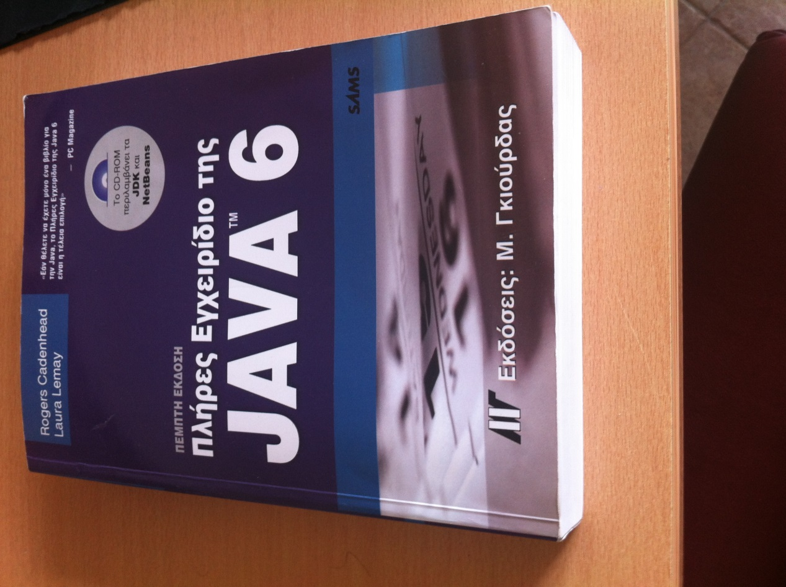

Many more hours than before above *“Java, How to program” (1500 pages)   
and “Program Development in Java.”*

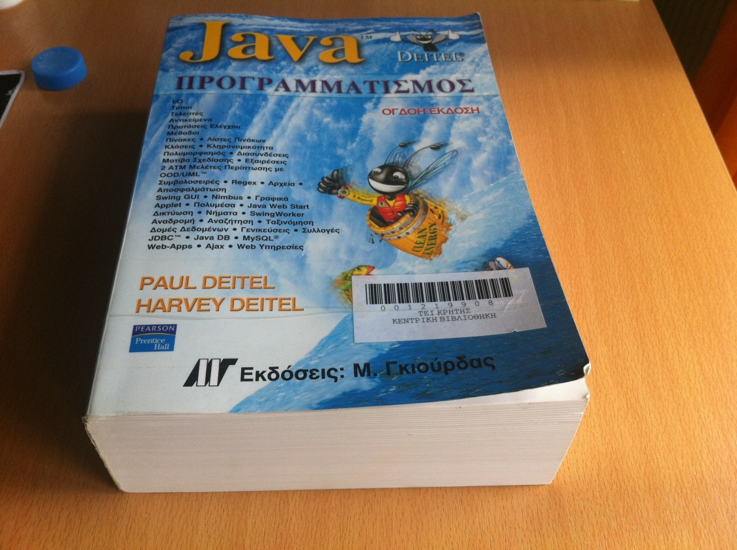

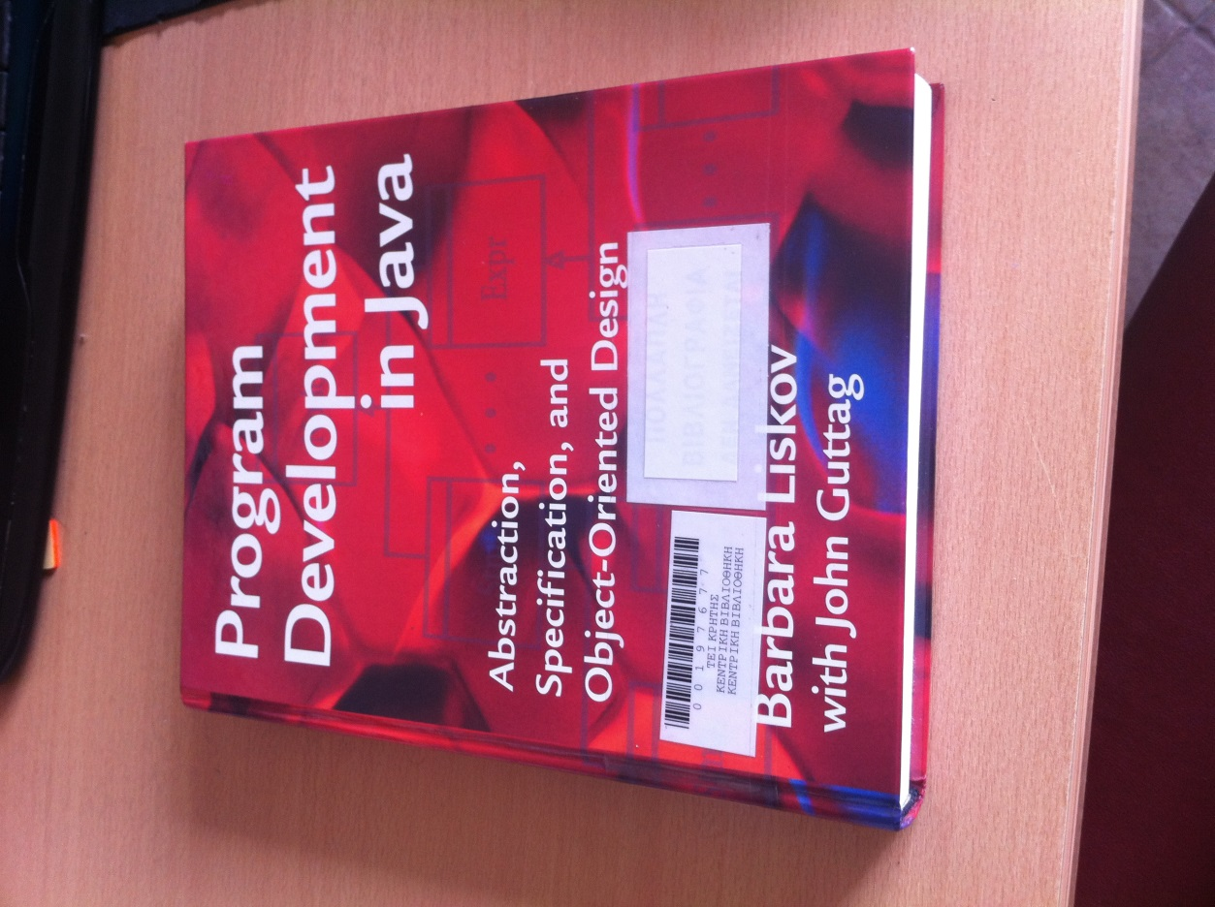

And less for *“Data Structure”:*

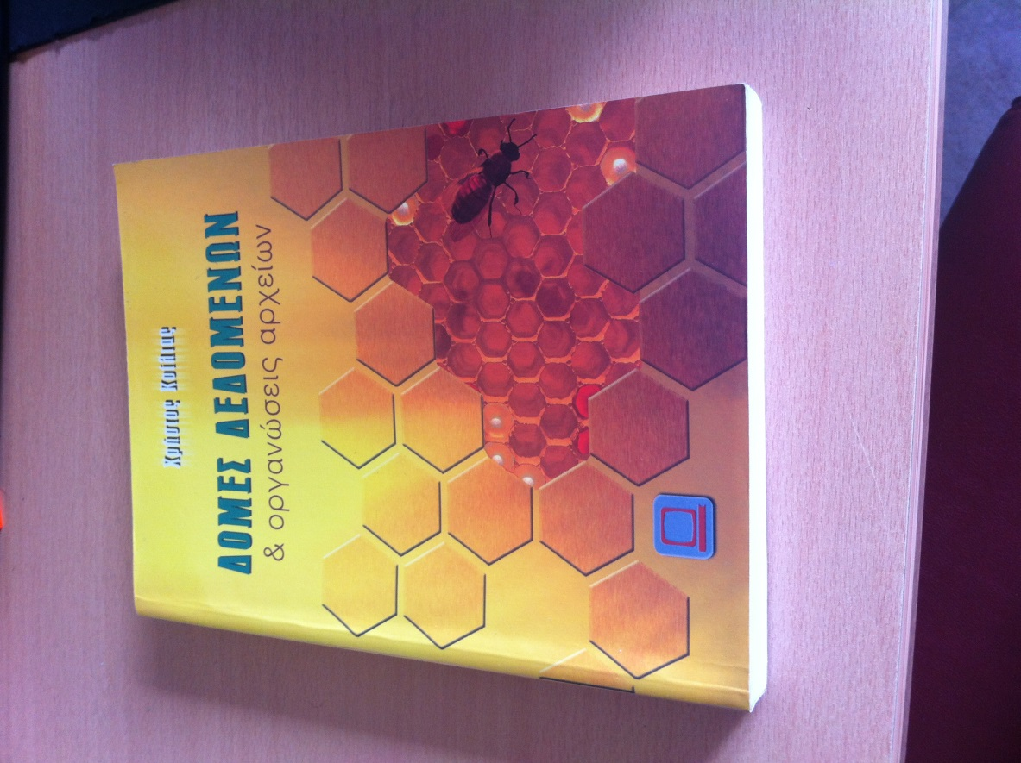

All the “Knowledge Tools” together !

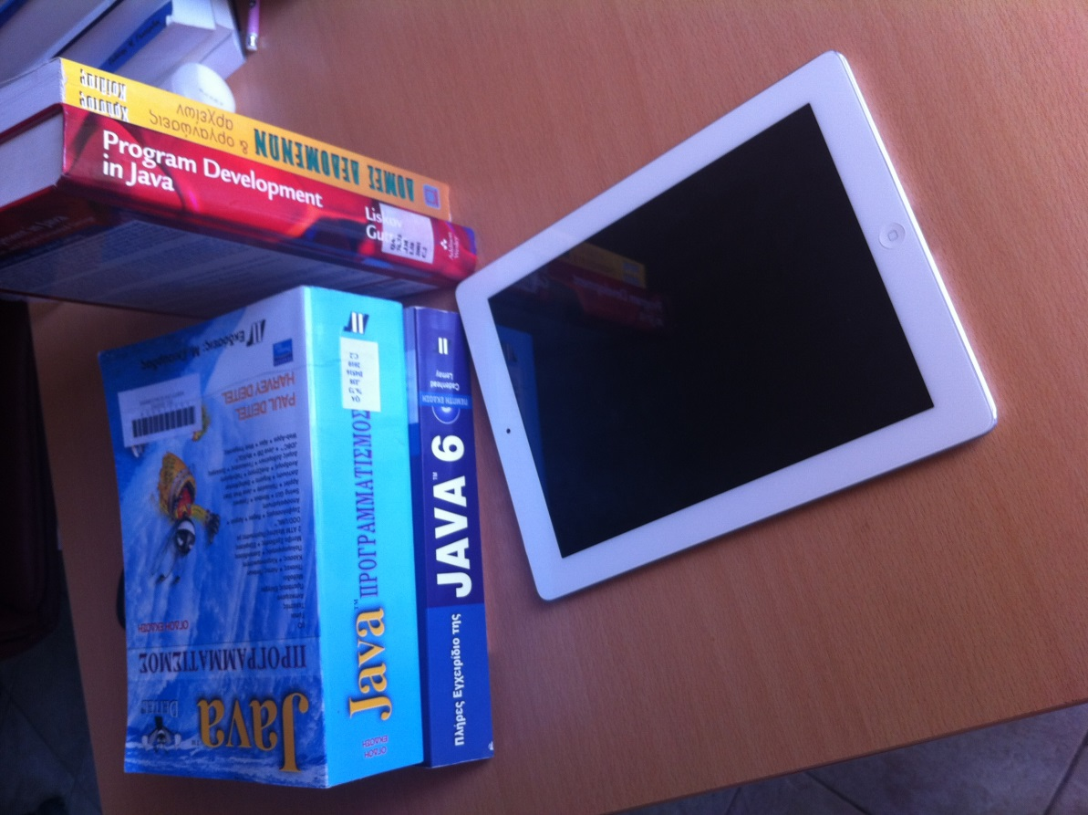

1. Immensely time in front of my workplace (excuse me for the untidiness)!

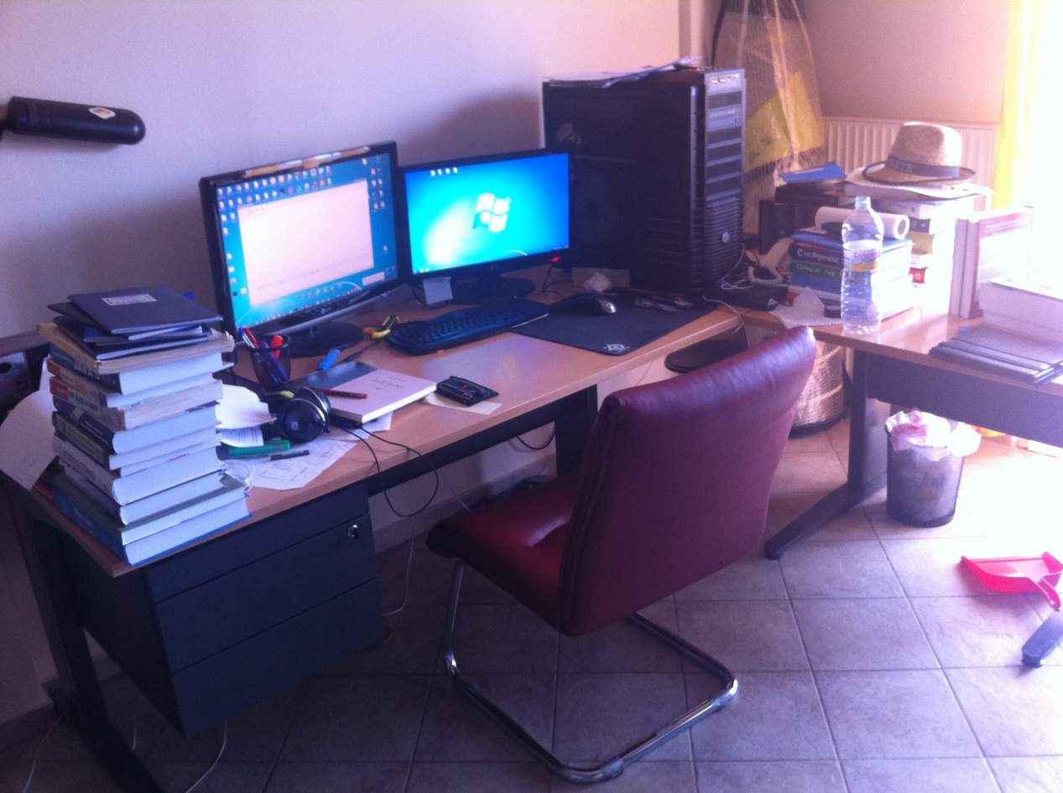

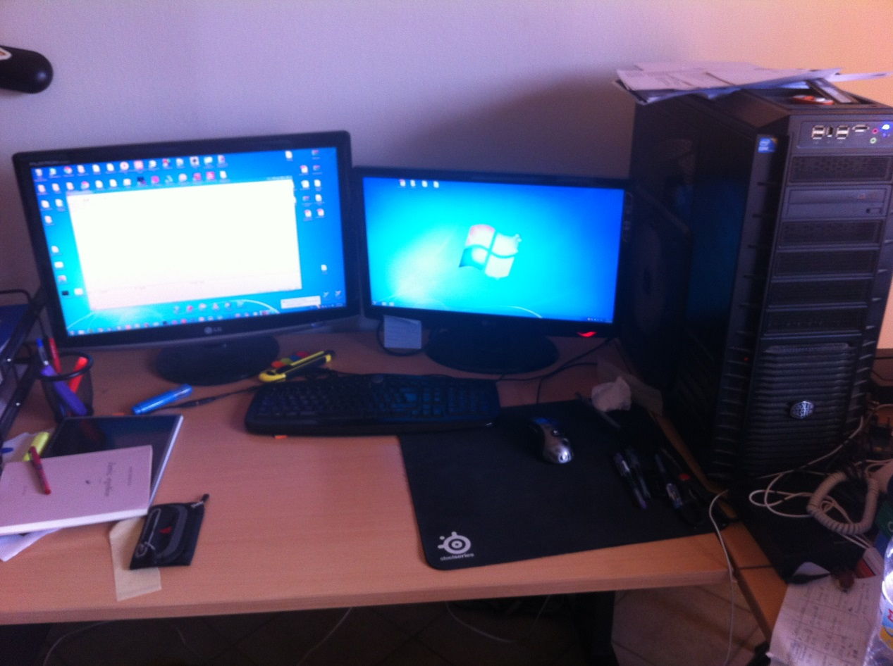

1. 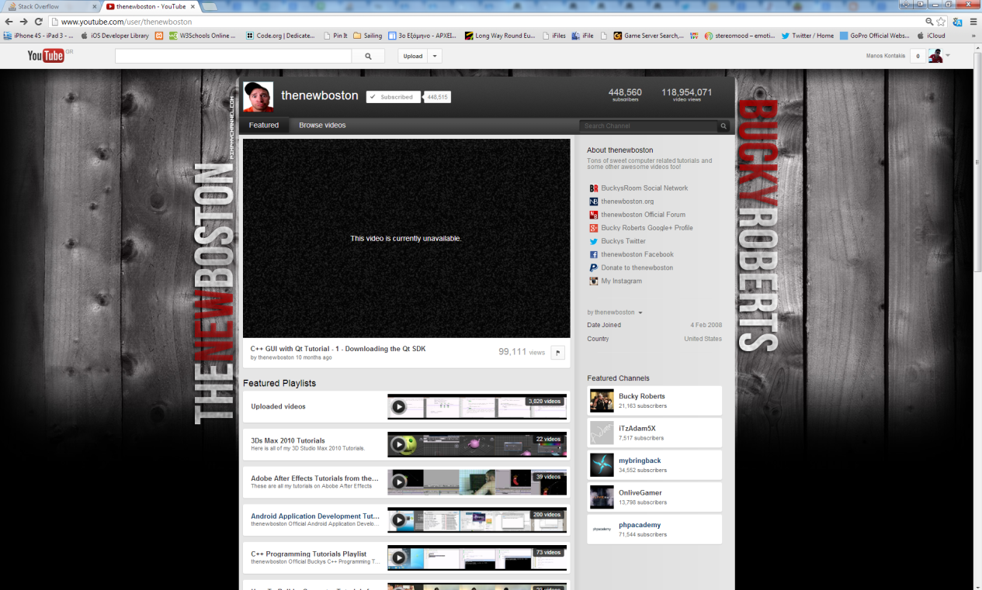I feel obliged to thank THENEWBOSTON for his awesome Java tutorials.
2. I would like to thank everyone who helped me at [www.stackoverflow.com](http://www.stackoverflow.com)  
   and curse everyone that is ironic and aggressive with the begginers.

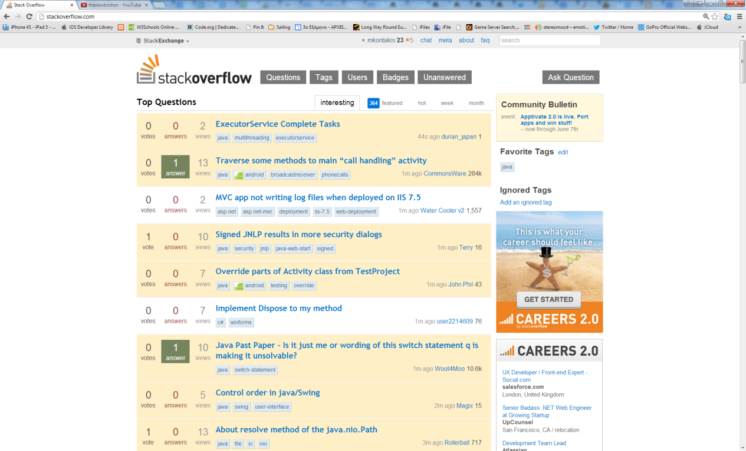

1. Finally I would like to thank my lecturers and Netbeans !

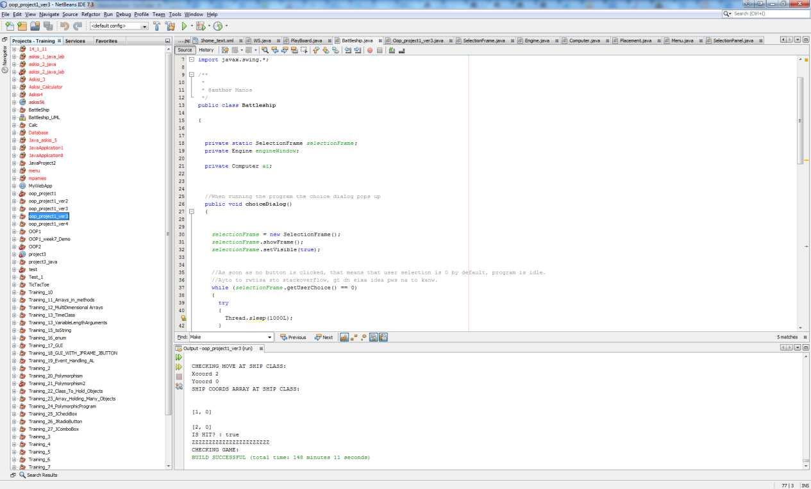

For the project to complete took three and a half months.

**EOF**